Annual Report
of SEBA

( For the year 2016-17)

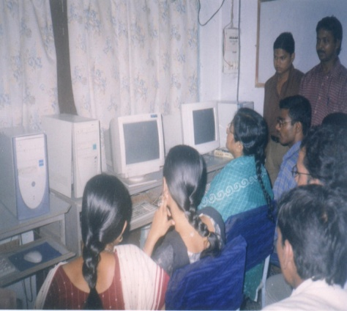
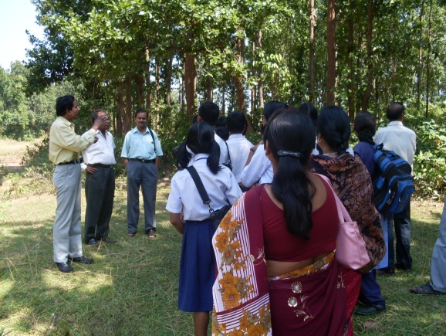
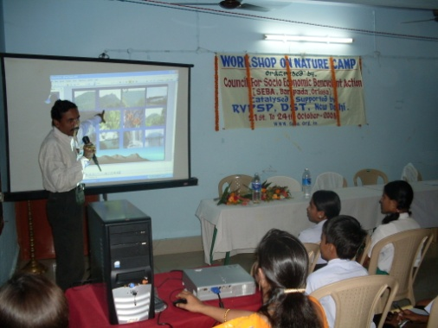

Council for Socio Economic Benevolent Action (SEBA)
At-Walliganj, Po-Bhanjpur, Dist-Mayurbhanj, Orissa, India, PIN-757002.
E-mail : seba.odisha@gmail.com
Website : www.seba.org.in

THE ORGANISATION

The Council for Socio Economic Benevolent Action / SEBA is an non profit making non political and non religious organisation, formed by a group of young and experienced professionals drawn from various trade and sector of the society, with a common desire to make meaningful contribution to the society, bearing IGR Registration no-22006 / 184, of 2004-2005, District Registration No-5918-424 of 1996-1997, and FCRA Rgn No-104990046. Working in Orissa since April 1994 with the aim for improving all round development of the society by focusing on Health, Education and development of Socio Economic standard of the people.

Focusing on the problem of global warming and consequences there of such as short fall in Agriculture, scarcity of water, the organisation works for improvement of surface and ground water management, as well as improvement in Education, Health & Socio Economic situation. SEBA has taken an integrated innovative approach to solve the problems. We have sufficient number of experienced and well qualified staff and strong group of committed volunteers to execute the various developmental projects.

In last years we got aid from Government of India, Department of Science & Technology, New Delhi for an amount of Rs. 1,10,500/- towards Nature Camp workshop, Rs. 1,11,000/- from Department of Science & Technology, New Delhi, to conduct ‘Training of Resource Teachers for conducting Open Ended Experiments on Life Sciences using Vermicomposting as a Base’, Rs. 10,000/- from the State Social Welfare Advisory Board, Orissa, towards Awareness Generation programme for Rural and poor women , Grant of Rs 71600/- from NABARD for Technical REDP Training on Bamboo Craft, Grant of Rs 1,80,000/- from Ministry of Textiles, Govt of India, New Delhi for Design Development in Bamboo craft. We have also completed one Check Dam in Village Nuadihi with CAPART's assistance of Rs. 2,10,166/-. We have organized the activities in Mayurbhanj district as nodal agency during the Year of Scientific Awareness-04 (A programme of NCSTC, DST, Govt of India) with assistance from Govt of India, Department of Science & Technology, New Delhi. We got books from Raja Rammohan Ray foundation twice for our Rural library. Our organisation is also got registration under section 80G of Income Tax Act 1961.

ACTIVITES

EDUCATION & LITERACY :

Our volunteers work for women & adult education and T.L.C. The literacy programme for the street and poor children drew more beneficiaries into its fold beside the regular classes where children of 6+ age group taught, attention has been given to start one school for the street children’s and children who earn for their
livelihood. The organization celebrated international literacy day on 8th September 2016 by organizing literacy camp at Nuadihi & Jatipur. Children took out marches around the village, with appropriate slogans. Distribution of study materials was done beside providing refreshment to all who were present .

Continued … p2

// 2 //

AGRICULTURE :
Our team of experts meets with the farmers & give them guidance for increase in production with the use of better quality of seeds, bio-fertilizer and latest innovative methods through out the year. Focusing on the problem of global warming and consequences there of such as short fall in Agriculture, scarcity of water, the farmers are guided for wise utilization of water and environment friendly agriculture. We promoted SRI agriculture in Kaptipada Block supported by Dept of Agriculture, Govt of Odisha.

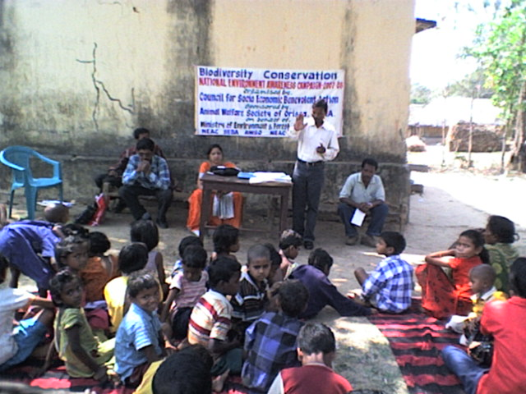
Training to skill development Education to children program by SEBA

HEALTH & AIDS PROGRAMME :

Various Health Programmes as well as Health Camp was organized on world Health day 7th April 2016 . One mobile Health camp was organized, in which four hundred persons of seven villages from various age group got free medical check up. RCH programme was also conducted. On world AIDS Day i.e. on 1st December 2016, AIDS awareness camp was organised to give first hand information to the vulnerable groups & truck drivers playing on the National High Way. Around five hundred participants from various social back ground attended the camp. On Anti leprosy day i.e. on 30.1.2017, Seminar & awareness campaign was undertaken for prevention of leprosy for the highly sensitive area Raghunathpur and rehabilitation for leprosy cured persons as well as FORD assisted programs were undertaken .

ENVIRONMENT AWARENESS PROGRAM :

Environment protection camp was organised in Nuadihi on World Environment Day 5th June 2016. Basic knowledge of environmental cleanliness and pollution was disseminated. Back yard plantation has been encouraged by distribution of fruit bearing plants among the villagers . One Demonstration of Vermin composting pit, was organized at village Sirishbani under Samakhunta Block, in the context of “Global warming” issues. on 28th February 2017. Public Meeting on the theme of “Swachha Bharat Abhiyan” was organized at Baripada. Dr Subrat Satapathy, Scientist, Sceri culture Department, Keonjhar, has joined as the Chief Resource person beside Mr Sisir Panda, Geologist and Ms BinaPani Panda, Principal, SVSS, Sirisbani, Baripada.

Continued … p3

// 3 //

SKILL UPGRADATION TRAINING FOR ARTISAN :

We are conducting various skill up gradation trainings for rural poor artisans from time to time in the sector of Tasar reeling and weaving, Bamboo, Sabai and other
Handicrafts, beside khali stitching for which we got support from Development Commissioner (Handicraft), Ministry of Textiles, Govt of India, New Delhi, UNIDO and NABARD.

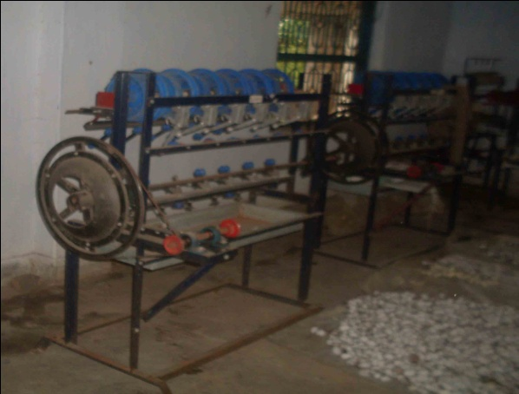
Bamboo craft training by SEBAi Improved Tasar reeling machine for
the reeling trainees
PROGRAMME FOR WOMEN & AWARENESS ON HUMAN TRAFFICKING :

On international women’s day 8th March 2017, seminar and awareness programme for rights of women and ‘Awareness program on Human Trafficking’ was conducted, in which Mr Rabindra Padhiari, Legal Advisor, SEBA, advised women’s about rights of women protection and Laws thereof , various mode of Human Trafficking and its affects on society, as well as how to control it was discussed .

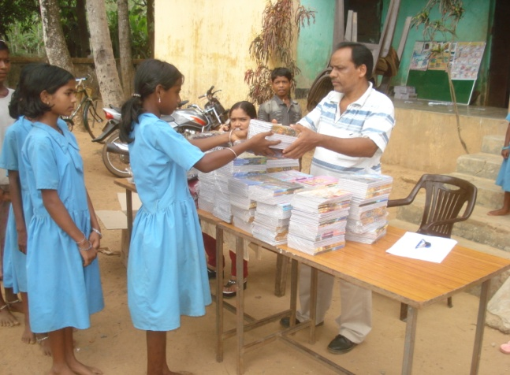 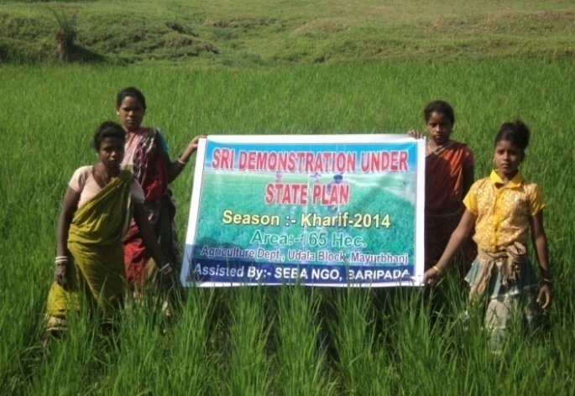 Distribution of study materials to Needy students Demonstration & Awareness on SRI Agriculture

ILU-HA ASSISTED PROGRAM :

Educational assistance such as distribution of Books, Note Book, Geometry Box etc has been distributed to 512 number of School going poor children, who were under the shadow of Leprosy, TB and AIDS, of Mayurrbhanj district. Beside this various leadership and talent
development activities such as Quiz, drawing, debate has been conducted among the school students. The programme was supported under Read to Lead Programme of International Leprosy Union – Health Alliance (ILU-HA) of Pune, Maharasthra.

Continued … p4
// 4 //

DISASTER RELIEF & REHABILITATION :

Our volunteers worked for relief and rehabilitation of slum dwellers during the flood of river Subernarekha and Budhabalanga. We have supplied cooked food and water by making a camp at village Tumudibandha during August 14-18 for the flood affected in Subernarekha.

SCIENCE & TECHNOLOGY :

On national science day i.e 28th February 2017, various competition among school students such as Quiz, Drawing etc on scientific themes were conducted among school going children of Baripada.
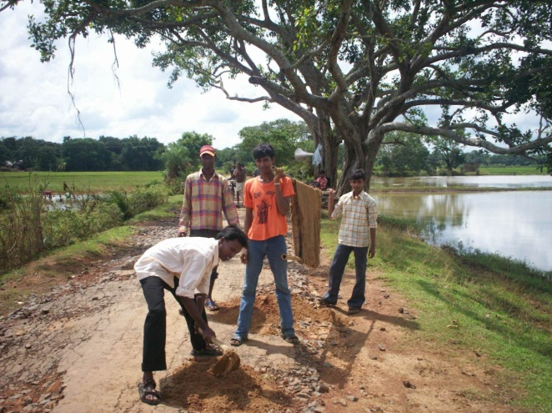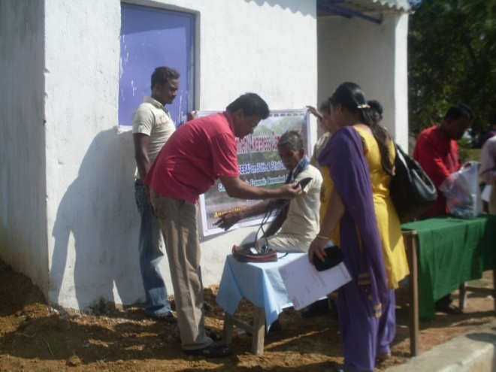
Work camp at village Khasadihi, Baripada. During Health camp

RURAL INDUSTRY SERVICE CENTRE PROGRAM :

Our professional Mr Pranab Mohapatra attended RuTag programme at IIT Kharagpur, in connection to promotion and development of various Rural based technology activities. Our organisation is promoting machineries for use by rural craft persons to enhance their income.

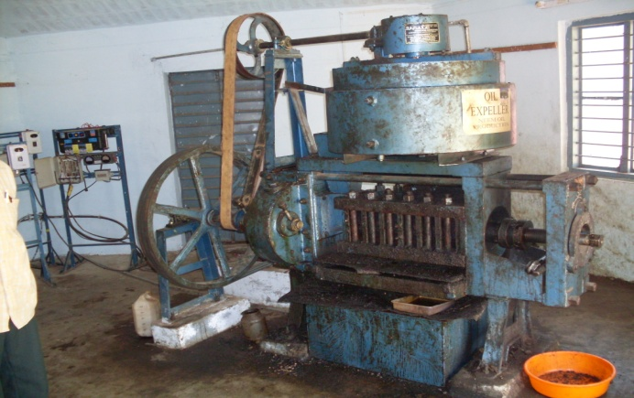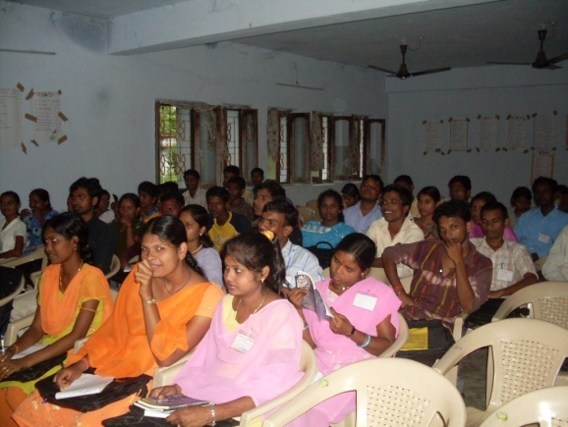
Extraction of oil from minor forest products During consumer awareness programme

Rural industry service center (RISC) program was initiated in line with RuTAG, IIT, Kharagpur. Where unemployed youths are given training in various income generation activities such as Soap making, Extraction of edible oil from minor forest products, Making of Handmade papers and Paper Bag etc. This year one sabai grass rope making machine
developed by RuTag unit IIT , Kharagpur, was introduced. The trainees were encouraged to setup there individual production units. We have also opened one Rural Technology Park at Nuadihi.

Continued … p5
// 5 //

CONSUMER RIGHTS PROGRAM :

On Consumer rights Day i.e on 15th March 2017, one Consumer rights program was conducted, in which around two hundred number of participant participated. The participants are given information regarding rights of consumer’s and protection thereof as per law .

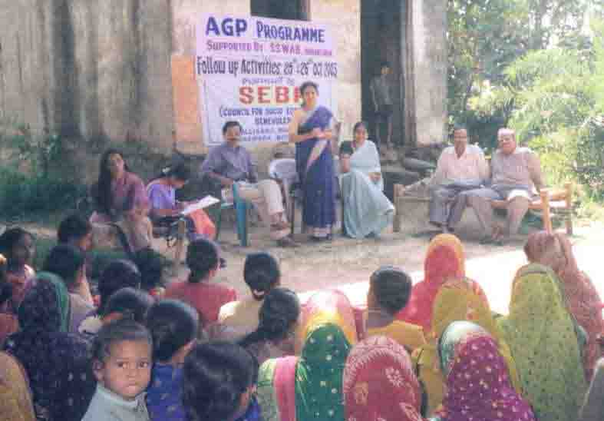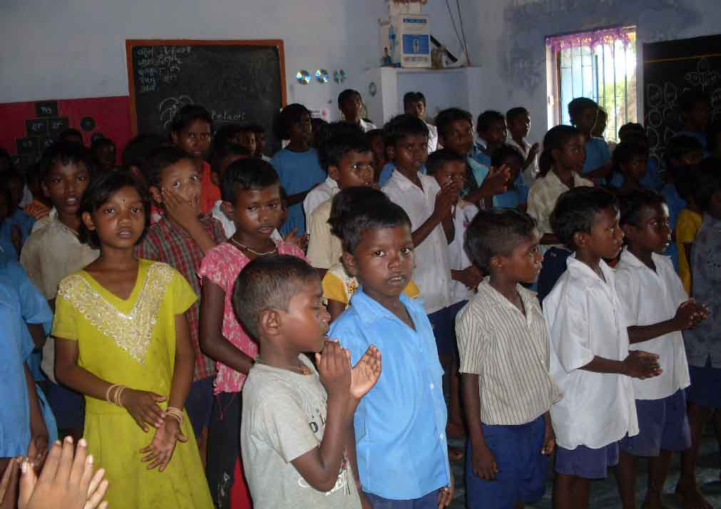
Interaction with women SHG groups on microcredit Interaction among students from different sector

ROAD SAFETY AWARENESS CAMPAIGN :

Road safety awareness campaign has been observed during January 2017, one
Seminar and Bi-cycle rally was also conducted in 14th January 2017, to create
awareness among Truck drivers for safe driving in National Highways. Some of the drivers who participated in last year has also participated and shared their experiences regarding practicising road safety measures.

PROGRAMME FOR AGED :

We continue our Aged care programme at Nuadihi in which Sixty plus Age group beneficiaries were provided health care facility along with day care center. An eye care camp was organized on 15th August 2016, where one hundred twety six aged persons checked their vision, beside free lenses and medicines were provided to them. Villagers requested for provision of one Mobile health care center for regular health facilities.
MICROCREDIT & SHG PROGRAM :

Our organization is a member of world Micro credit summit, a federation of women SHG’s has been done in Hatikote GP, including seventeen villages of the GP, where five hundred sixty number of women comprising fifty six SHG’s are together for enhancement of their income as well as all round development.

Beside the above activities other Socio-Economic programmes such as Forest
protection, Rural sanitation, Malaria & TB eradication , RCH Programme, activities on Handicraft & Cottage industry, Rehabilitation of leprosy cured persons, Watershed Management programmes and Community library facilities with support of RRLF continued.

Date : 15th April 2017 . ( R. N. Mishra )
Place : Baripada. Chairman, SEBA

